***Superior University Lahore***

***Gold Campus***

***Department Of Information & Technology***

***Mobile Application and Development***

***Assignment: 1***

***Name*:**

**Abdul Basit** (Bitm-F19-046)

**Section:**

BSIT 6A

**Submitted To:**

Sir Javaid Iqbal

**Code:**

<?xml version="1.0" encoding="utf-8"?>  
<LinearLayout xmlns:android="http://schemas.android.com/apk/res/android"  
 xmlns:app="http://schemas.android.com/apk/res-auto"  
 xmlns:tools="http://schemas.android.com/tools"  
 android:layout_width="match_parent"  
 android:layout_height="match_parent"  
 android:orientation="vertical"  
 android:layout_gravity="center_horizontal"  
 tools:context=".MainActivity">  
 <ImageView  
 android:layout_width="361dp"  
 android:layout_height="298dp"  
 android:layout_gravity="center"  
 android:src="@drawable/ty" />  
  
 <TextView  
 android:layout_width="wrap_content"  
 android:layout_height="wrap_content"  
 android:text="Welcome"  
 android:textSize="45dp"  
 android:textStyle="bold"  
 android:textColor="@color/black"  
 android:layout_marginTop="30dp"  
 android:layout_gravity="center"  
 />  
  
 <TextView  
 android:layout_width="wrap_content"  
 android:layout_height="wrap_content"  
 android:layout_gravity="center"  
 android:layout_marginTop="20px"  
 android:text="Create a new account"  
 android:textColor="@color/black"  
 android:textSize="18dp"  
 android:textStyle="bold"  
 />  
  
 <Button  
 android:id="@+id/Button1"  
 android:layout_width="350dp"  
 android:layout_height="50dp"  
 android:layout_gravity="center"  
 android:layout_marginTop="40dp"  
 android:text="Login"  
 android:textColor="@color/black"  
 android:textSize="18dp"  
 android:textStyle="bold" />  
  
  
</LinearLayout>

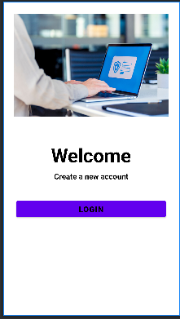

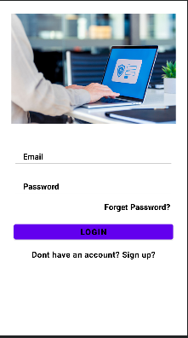

Link:

<https://github.com/AbdulBasit011/Myapp1.git>